**Course Manual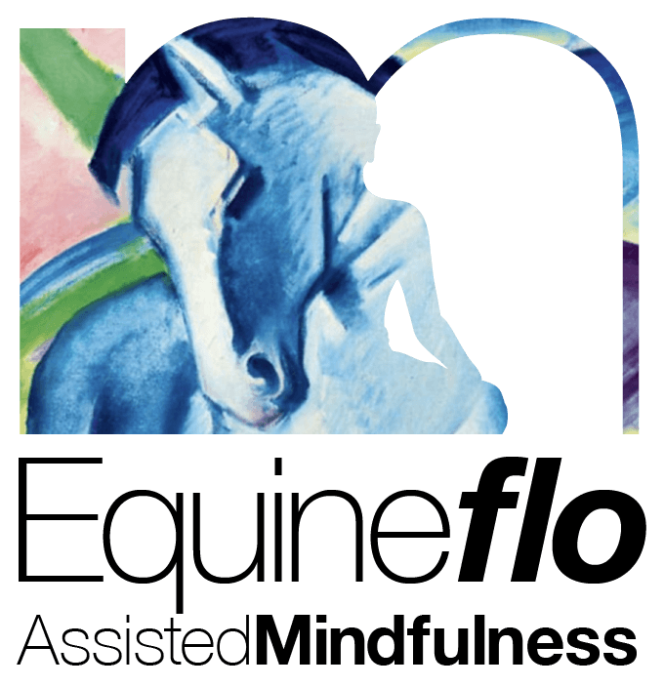 Outline for Advanced Equine Assisted Mindfulness**  
1. Introduction

   - Overview of the Advanced Course  
   - Objectives: Building on previous mindfulness skills, integrating positive psychology, and deepening compassion practices.   
  
2. Theoretical Background

   - Introduction to Strength-Based Psychology  
   - Fundamentals of Positive Psychology  
   - Understanding and Practicing Compassion   
  
3. Session Structure

   - Weekly Themes  
   - Practical Applications with Horses  
   - Integrative Mindfulness Practices   
  
Weekly Session Plans   
  
Week 1: Strength-Based Foundations

*Goals:*  
- Introduction to strength-based psychology principles.  
- Applying these principles in the context of equine interactions.   
  
Activities:

1. Housekeeping and Introduction (10 mins)  
   - Refresh on confidentiality, health and safety.  
2. Strengths Identification Exercise (30 mins)  
   - Identifying personal strengths and discussing how these can be observed in equines.  
3. Guided Mindfulness Practice with Horses (30 mins)  
   - Focus on embodying strengths during interaction with horses.  
4. Group Reflection and Discussion (20 mins)   
  
Week 2: Positive Psychology and Equine Interaction

*Goals:*  
- Exploring key concepts of positive psychology.  
- Integrating these concepts into mindful equine practices.   
  
Activities:

1. Review and Housekeeping (5 mins)

2. Didactic Learning: Positive Psychology Basics (20 mins)  
   - Discussion of core concepts such as gratitude, optimism, and resilience.  
3. Equine Interaction Activity (30 mins)  
   - Practicing gratitude and optimism with horses.  
4. Nature-Based Mindfulness M (30 mins)  
   - Guided practice focusing on positive emotions.  
5. Enquiry and Sharing Session (15 mins)   
  
Week 3: Deepening Compassion

*Goals:*  
- Understanding and enhancing compassion for self and others.  
- Applying compassionate practices in equine-assisted mindfulness.   
  
Activities:

Housekeeping Reminder (5 mins)  
2. Discussion on Compassion (20 mins)  
   - How compassion works, both psychologically and in relation to equines.  
3. Compassionate Interaction with Horses (30 mins)  
   - Engaging in grooming and bonding activities.  
4. Mindfulness Practice: Compassion Meditation (30 mins)  
5. Group Enquiry and Reflection (15 mins)

Week 4: Integration and Practical Applications

*Goals:*  
- Integrating all learned concepts into a cohesive practice.  
- Reflecting on growth and setting future intentions.   
  
Activities:

1. Housekeeping and Review (5 mins)  
2. Consolidation Activity (30 mins)  
   - Review of key takeaways from previous weeks.  
3. Guided Integration Practice with Horses (30 mins)  
   - Applying strength-based, positive psychology, and compassion principles in a mindful session.  
4. Group Discussion and Q&A (20 mins)  
   - Reflecting on experiences, discussing challenges and successes.  
5. Closing Meditation and Future Intentions (15 mins)

**[www.letsflomindfully.co.uk](http://www.letsflomindfully.co.uk)**

[enquiries@letsflomindfully.co.uk](mailto:enquiries@letsflomindfully.co.uk?subject=New%20client%20intake%20questionaire)

