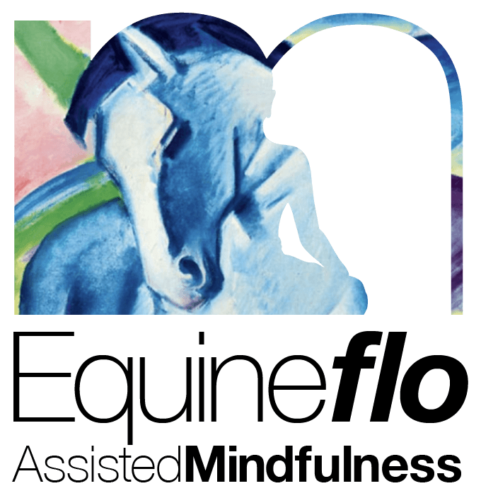

**Course Manual Outline**

1. Introduction

   Course Overview: Introduction to Mindfulness With Equines (MWE), 4 sessions, each lasting 2 hours.

Objectives:

     - Understand Mindfulness in nature and with horses by identifying and drawing on our strengths.

     - Comprehend Mindful Attitudes in Equine interactions.

     - Explore neurobiology, polyvagal theory, and sensory awareness in humans and equines.

     - Learn grounding techniques and Nature & Equine assisted Mindful meditations.

     - Enhance confidence in practicing Mindfulness, aiding steadiness for humans and horses.

     - Develop compassion through practice with horses.

     - Engage in self-inquiry before, during, and after Mindfulness practices.

2. Theoretical Framework

   - Strength-Based Approach: Focus on personal strengths and positive experiences.

   - Mindfulness-Based Strengths Practice (MBSP):Principles applied to the human-equine relationship.

   - Neurobiology and Polyvagal Theory: Key concepts from Dr. Stephen Porges' work, applied to equine behaviour.

3. Session Structure

   - Weekly Themes and Activities:Detailed session plans.

   -Facilitator’s Guide: Tips and safety guidelines for conducting sessions.

   - Assessment and Feedback: Use of mindfulness assessment tools and formative and summative assessments.

**Weekly Session Plans**

Session 1: Body Connection for Humans and Horses

Activities:

  - Housekeeping: Confidentiality, Health and Safety, Community Guidelines.

  - Finding steadiness in the body with equines, understanding senses, trauma responses.

  - Body Scan Meditation with Equine assistance.

  - Self-Enquiry to support understanding of practices and responses.

Session 2: Heart and Mind Mirroring

Activities:

  - Housekeeping reminder.

  - Polyvagal Theory applied to humans and equines.

  - Discussion on equine behavior and emotions.

  - Guided nature meditation with horses.

  - Enquiry and reflection on the meditation.

Session 3: Tricky Situations

Activities:

  - Housekeeping reminder.

  - Practice reacting to difficult situations, comparison with equine responses.

  - Mindfulness Meditation for compassion in mild difficulty.

  - Enquiry into the meditation experience.

Session 4: Horse Care as Self-Care and Compassion

Activities:

  - Compassionate grooming session.

  - Learning empathy and compassion from horses.

  - Consolidation of 4 weeks learning.

  - Mindfulness Meditation to share Compassion with equine companions.

  - Enquiry and reflections.

Additional Activities

- Sharing Equine Assisted Mindfulness and Meditation experiences.

- Group meditation and discussions in natural settings.

- Small group activities and breakout rooms.

- Use of slides and visual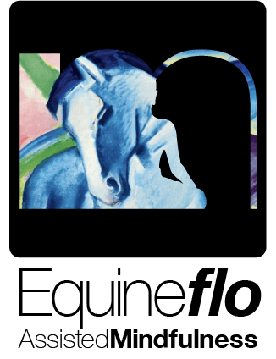 aids for theoretical concepts.

**[www.letsflomindfully.co.uk](http://www.letsflomindfully.co.uk)**

[enquiries@letsflomindfully.co.uk](mailto:enquiries@letsflomindfully.co.uk?subject=New%20client%20intake%20questionaire)

 Assessments

- Questionnaires and Scales: MAAS, Five-Facet Mindfulness Questionnaire.

- Formative and Summative Assessments: Regular feedback and formal assessments like case study.

