*The Basic Retreat and the Advanced Retreat can be offered as stand alone day Retreats or together as a weekend Retreat.*

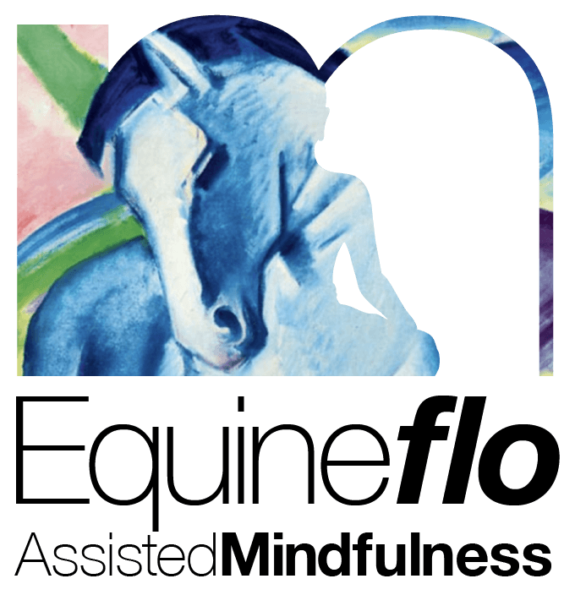**Basic Equine Assisted Mindfulness Day Retreat**   
  
Schedule:

- 9:00 AM - 9:15 AM: Welcome and Introduction  
  - Brief overview of the day, housekeeping, and introductions.   
  
- 9:15 AM - 10:00 AM: Mindfulness and Body Awareness  
  - Activity: Gentle introduction to mindfulness. Icebreaker activity.  
  - Body Scan Meditation: Focus on body awareness with equines.   
  
- 10:00 AM - 10:30 AM: Movement Practice  
  - Gentle yoga or movement session, incorporating breathing and posture.   
  
- 10:30 AM - 11:00 AM:Discussion: Mindfulness in Nature  
  - Overview of mindfulness principles and their application with horses.   
  
- 11:00 AM - 12:00 PM: Equine Interaction and Mindfulness Practice  
  - Activity: Practical session with horses, focusing on grounding techniques and body awareness.  
  - Self-Enquiry: Group discussion on experiences and insights.   
  
- 12:00 PM - 1:00 PM: Lunch Break  
  Catered nourishing meal optional.   
  
- 1:00 PM - 2:00 PM: Exploring the Senses and Polyvagal Theory  
  - Activity: Sensory awareness exercises with horses.  
  - Polyvagal Theory Discussion: Applying theory to human and equine interactions.   
  
- 2:00 PM - 2:30 PM: Movement Practice  
  - Gentle movement or yoga session focusing on relaxation and balance.   
  
 - 2:30 PM - 3:30 PM: Mindfulness Meditation and Compassion Practice  
  - Activity: Guided mindfulness meditation with equines.  
  - Compassion Practice: Exercises to cultivate compassion for self and others.   
  
- 3:30 PM - 4:00 PM: Reflection and Closing  
  - Group discussion, reflections on the day, and closing remarks.   
  
**Advanced Equine Assisted Mindfulness Day Retreat**   
  
Schedule:

- 9:00 AM - 9:15 AM: Welcome and Introduction  
  - Brief overview of the day, housekeeping, and introductions.   
  
 - 9:15 AM - 10:00 AM: Strength-Based Psychology and Mindfulness  
  - Activity: Introduction to strength-based principles and identifying personal strengths.  
  - Mindfulness Practice: Focus on embodying strengths with equines.   
  
- 10:00 AM - 10:30 AM:Movement Practice  
  - Gentle yoga or movement session, emphasizing strength and flexibility.   
  
 - 10:30 AM - 11:00 AM: Positive Psychology and Gratitude  
  - Discussion: Key concepts of positive psychology and the application with horses.  
  - Activity: Gratitude practice with horses.

- 11:00 AM - 12:00 PM: Equine Interaction and Nature Meditation  
  - Activity: Mindfulness practice with equines, incorporating natural elements.  
  - Nature-Based Meditation: Guided meditation focusing on nature and gratitude.   
  
 - 12:00 PM - 1:00 PM: Lunch Break  
  - Catered nourishing meal optional..   
  
 - 1:00 PM - 2:00 PM: Exploring Compassion with Equines  
  - Activity: Compassionate interaction with horses.  
  - Discussion: Understanding and enhancing compassion for self and others.   
  
- 2:00 PM - 2:30 PM: Mo event Practice to help find Flowstate with horses.   
  
- 2:30 PM - 3:30 PM: Integration and Mindfulness Practice  
  - Activity: Applying strength-based, positive psychology, and compassion principles in a mindful session with equines.  
  - Enquiry Session: Group discussion and reflection on personal growth and insights.   
  
- 3:30 PM - 4:00 PM: Reflection and Closing  
  - Group discussion, reflections on the day, and closing remarks.

**[www.letsflomindfully.co.uk](http://www.letsflomindfully.co.uk)**

[enquiries@letsflomindfully.co.uk](mailto:enquiries@letsflomindfully.co.uk?subject=New%20client%20intake%20questionaire)

