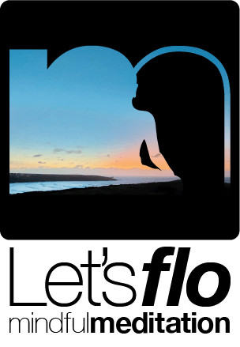

|  | New client intake questions | **Yes/No** |
| --- | --- | --- |
|  | We understand these questions are very personal and as such you have our 100% commitment to confidentiality.  We rely on your full and honest disclosure to ensure this day of mindfulness is the best and safest course for you. |  |
| Have you practised mindfulness of meditation before, please list experience? |  |  |
| What do you hope to get from the course? |  |  |
| How would you know if it has been effective? |  |  |
| What current stressors do you have in your life? |  |  |
| Are there past experiences that still cause you stress? |  |  |
| Do you have a history of trauma?  If so do you actively experience symptoms such as flashbacks, nightmares or difficulty with attention? |  |  |
| Are you currently seeing a therapist or councillor and if so do they know about this course of mindfulness? |  |  |



|  | New client intake questions cont. | **Yes/No** |
| --- | --- | --- |
| Have you considered or attempted to take your life and if so are you willing to tell me a little more? |  |  |
| Do you take medication for phsycologial issues? |  |  |
| Do you have specific physical health issues and if so please list? |  |  |
| Do you have :  Asthma or breathing difficulties |  |  |
| Epilepsy |  |  |
| Low blood pressure |  |  |
| Diabetes? |  |  |
| Do you take medication and if so please list? |  |  |
| Are there any other health or background considerations you think I should be aware of? |  |  |
| Is there anything else you would like me to know? |  |  |
|  |  |  |

**[www.letsflomindfully.co.uk](http://www.letsflomindfully.co.uk)**

[enquiries@letsflomindfully.co.uk](mailto:enquiries@letsflomindfully.co.uk?subject=New%20client%20intake%20questionaire)